March 26, 2014

The Honorable Gerry Connolly

424 Cannon House Office Building

Washington, D.C. 20515

Dear Congressman Connolly:

On behalf of the five million federal employees, retirees and their survivors represented by the National Active and Retired Federal Employees Association (NARFE), I thank you for introducing the Federal Adjustment of Income Rates (FAIR) Act of 2014. We continue to appreciate your steadfast support for the federal workforce.

The 3.3 percent pay increase for federal employees, proposed in your bill, would help to close the growing gap between public- and private-sector pay – now at 35 percent, according to the Federal Salary Council, based on Bureau of Labor Statistics data. As you well know, federal employees had their pay frozen for three years and received only a 1 percent raise this year. Meanwhile, private-sector wages have risen 6.5 percent in the past four years, and the cost of living increased 7 percent during that time. On top of that, new employees are now forced to pay 4.4 percent more toward retirement without any additional benefit. Over the past four years, federal employees have contributed over $120 billion towards deficit reduction. It’s time we thank them for their service and sacrifice, rather than continue to devalue it.

Without competitive pay, we will fail to recruit and retain the best and brightest into public service. We rely on these men and women to take criminals off our streets and keep them behind bars; assist our military at home and abroad; care for veterans that have returned home; help prepare us and recover from severe weather; and much more. Providing our public servants adequate compensation is about more than just fairness, it is about maintaining an efficient and effective federal government.

Thank you again for your leadership in standing up for federal employees, in both message and action. If there is anything more we can do to help move this bill forward, please contact NARFE Legislative Director Jessica Klement at 703-838-7760 or [jklement@narfe.org](mailto:jklement@narfe.org).

Sincerely,

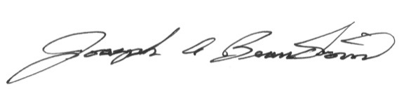

Joseph A. Beaudoin

National President